
KONERU LAKSHMAIAH EDUCATION FOUNDATION
(Deemed to be University estd, u/s, 3 of the UGC Act, 1956) Green Fields, Guntur District, A.P., India – 522502
Department of Electronics and Communication Engineering
(DST - FIST Sponsored Department)
Course Code: 24SDEC01R Program: B.Tech - ECE
Course Title: ELECTRONIC SYSTEM DESIGN Academic Year: 2025-26-II/IV-II Sem
SKILL EXPERIMENTS RESULTS :
STUDENT NAME: Y. Harshavardhan STUDENT ID: 2400040454
EXP. No.: 8 DATE:

TITLE OF THE EXPERIMENT: : Designing a Clock Signal Generator circuit, focusing on PCB Artwork.
AIM: To design a clock signal generator circuit that provides a stable clock output.
COMPONENTS REQUIRED:
EasyEDA software
A computer with an internet connection
A schematic of the Clock Signal Generator
CIRCUIT DIAGRAM:
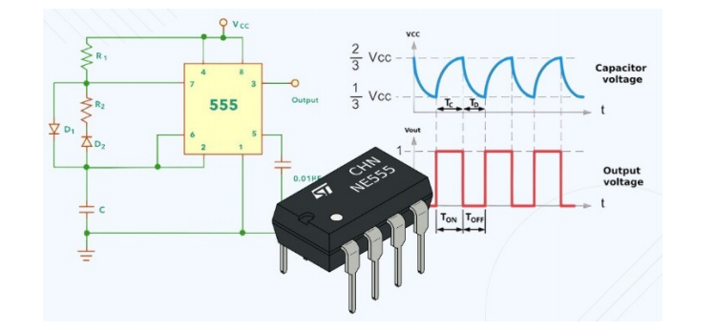

SCHEMATIC:
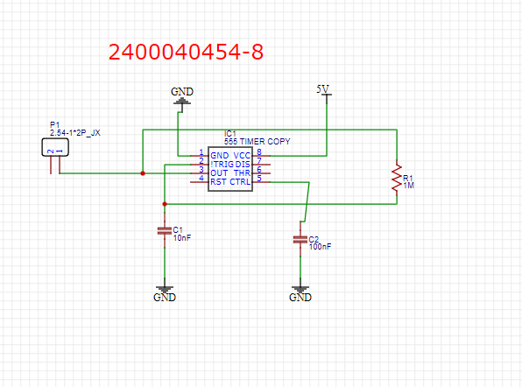

PCB LAYOUT:
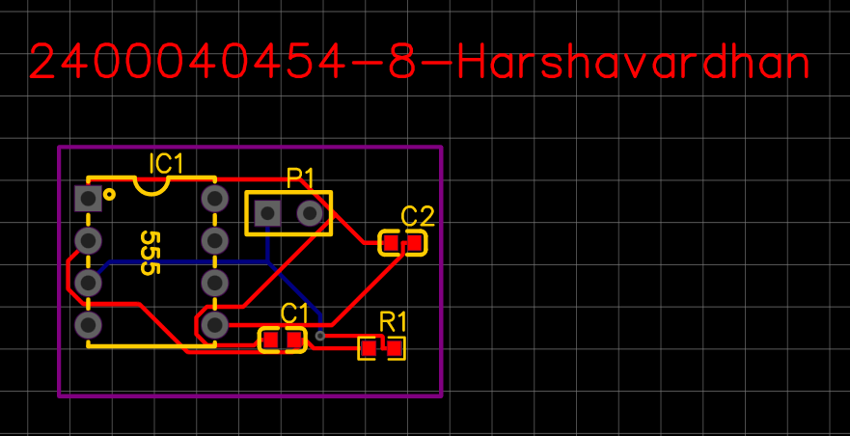

2D VIEW:
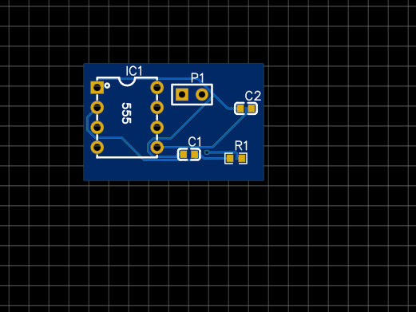

3D VIEW:
